Modern Times – Full text template

Ch. Chaplin1, P. Goddard2, H. Bergman3…

1 Affiliation 1, Department, Address, City, Country,*

2 Affiliation 2, Department, Address, City, Country

3. Affiliation 3, Department, Address, City, Country

Abstract

Modern Times is a 1936 American comedy written and directed by Charlie Chaplin. The main character, a tramp struggles to survive in the modern, industrialized world. The film sheds light on the desperate employment and financial conditions many people faced during the Great Depression. The movie is a bitter criticism of the conditions created, in Chaplin's view, by the efficiencies of modern industrialization.

Keywords

Modern; Factory; Assembly line; Humour; CIEC18 (*4-5 maximum*)

Introduction

The story begins in a factory working where the Tramp is employed on the assembly line. His job consists in screwing nuts at an ever-increasing rate as part of the assembly line as well as being subjected to new, untested inventions like an 'automatic feeding machine' (Fig. 1). After getting stuck within a machine and throwing the factory into chaos, he is then sent to the hospital. Following his recovery, he is arrested for being taken into a communist [1] demonstration.

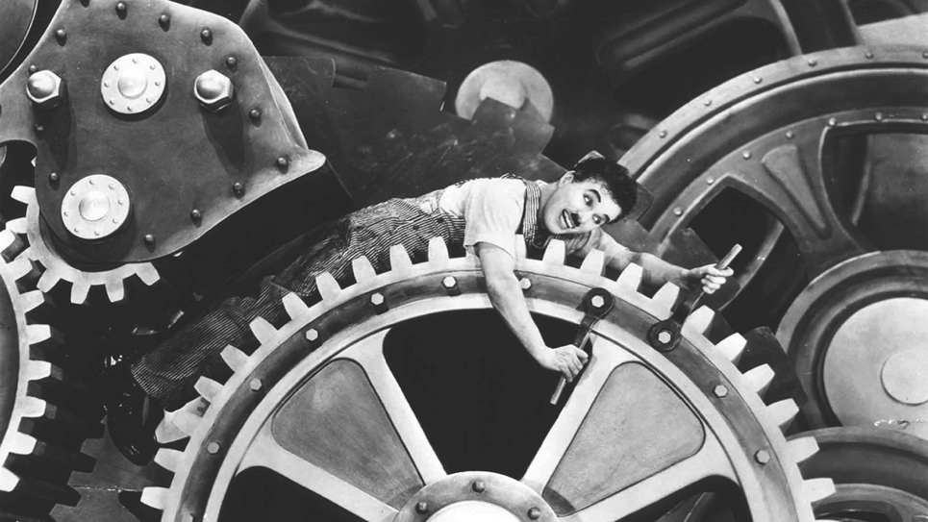

Fig. 1. Screwing nuts and bolts.

In jail, after a number of unlikely and comical situations, he hinders a jailbreak and is released as a hero. The jail guards need even to force him out since the Tramp prefers prison to the outer world.

Results and discussion

Upon release, he applies for a new job with a shipbuilder but leaves after causing an accident. Soon after, he runs into an orphaned girl, Ellen, who is fleeing the police after stealing a bread loaf. Determined to go back to jail and to save her from arrest, the Tramp accuses himself of the theft and demands to be arrested. A witness reveals his subterfuge and the police lets him free. The Tramp continues his attempts to be set back into prison. He eats an enormous amount of food at a cafeteria without paying to get arrested, and encounters Ellen again in a paddy wagon directed to prison. However, the wagon has an accident, and she convinces him to escape with her. The Tramp manages to get a job as a night watchman [2] at a store. He encounters three burglars led by "Big Bill," a fellow worker from the factory, who explains that they are just hungry and desperate. After sharing drinks with them (Fig. 2), he wakes up the next morning during opening hours and is arrested once again since he did not call the police on the burglars.

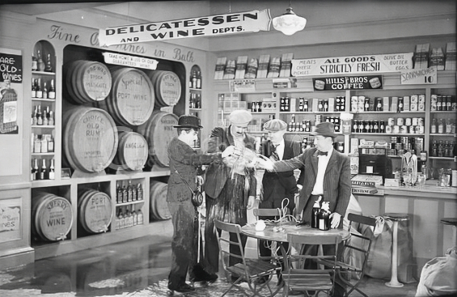

Fig. 2. The Tramp and the burglars in the department store.

Days later, Ellen convinces him to join her in a modest hut to live in. The next morning, he reads about an old factory’s re-opening and obtains a new job as a mechanic assistant. But the workers decide to go on strike, and ask the Tramp to join the movement. Outside the factory, he accidentally launches a brick at a policeman and is arrested again.

He is released two weeks later, and learns that Ellen is now a café dancer. She gets him a job as a singer and waiter, but he goes about his duties clumsily. During his show, he loses his cuffs, in which the lyrics of his song are hidden, but he rescues the act by improvising [3] the lyrics talking nonsense and by pantomiming (Fig. 3). The song “titine” remains one of the masterpieces of Chaplin’s repertoire.

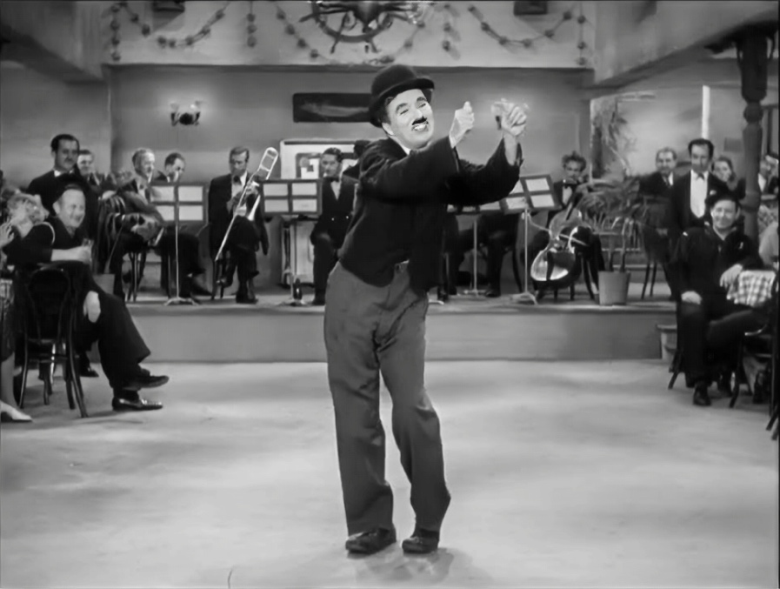

Fig. 3. Show in the café.

Conclusions

When the police arrive to arrest Ellen for her earlier escape, the two are forced to flee again, and Ellen seems resigned to a life in which all their struggles are all pointless. Nonetheless, the Tramp reassures her. In the iconic final view at dawn (Fig. 4), they walk down the road towards an uncertain but hopeful future.

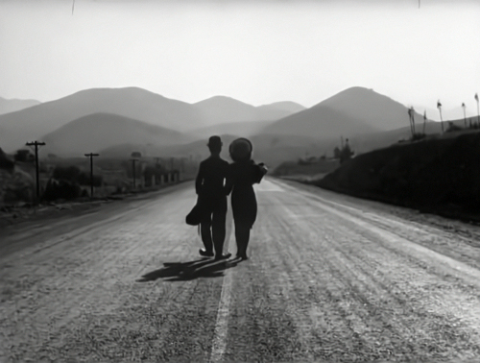

Fig. 4. Hoping in a better future.

Acknowledgements

The authors are grateful to the JECS Trust for funding (Contract No. 000000).

References

*Reference to a book:*

[1] Karl Marx, *Capital: A Critique of Political Economy*, trans. S. Moore and E. Aveling, The Modern Library, New York, 1906

*Reference to a chapter in an edited book:*

[2]. P. Rawlings, *Policing: A Short History*, Willan Publishing, 2002, pp. 64-69

*Reference to a journal publication:*

[3] ‘Modern Times’ and the Comedy of Transformation”, Literature/Film Quarterly*,* 15, 4, (1987) 219–226

**Max 4 pages for oral and poster communications**